Software Requirement Specification

for

Service Request management

(Admin Panel)

Created by:

Mayuresh Warade

SE2, India.

27/08/2020

# 1. Executive summary

* In admin panel particular admin of department will have access to all request generated towards his/her department.
* Admin can view all request with some necessary details in tabular form and also service request details by selection.
* Admin can assign request to employee under his department who has role of “Resource”.
* Admin will be also able to change service request status of request.
* After updating request all stakeholder in request will be notified by email.

# 2. Purpose and scope

## 2.1 PURPOSE

* Purpose of admin panel is to give consolidated access to service request across department.
* Admin panel should be easy to handle, reduce load to maintain request across department.

## 2.2 SCOPE

* Scope of Admin panel system will help to create a convenient and easy-to-use application for Administrator in Company.

# 3. Software Overview

## 3.1 UI Overview

## 3.1.1 Dashboard Screen

## 3.1.1 Form Fields

This will be grid, Admin will be able to see all the requests created for the department. Admin can filter the service requests. Filter can be Status, Date, and Category etc.

|  |  |  |  |  |  |
| --- | --- | --- | --- | --- | --- |
| Name | Data Type | Size | Values | Validation | Comments |
| Service Request No | Integer | 10 |  |  |  |
| Department | Enum | 20 | IT, Admin, Finance, Other |  |  |
| Request Category | Enum | 20 | Hardware, Software, Travel booking, Salary Issue |  |  |
| Request Sub Category | Enum | 20 | Laptop, Mouse, Keyboard, International travel ticket, Salary calculation |  |  |
| Summary | String | 250 |  |  | Display short text (20 char) and display complete summary on mouse click in popup. |
| View | Button |  |  |  | Open the Service request details screen |

## 3.1.2 Service Request Details screen:

## 3.1.2.1 Form Fields

|  |  |  |  |  |  |
| --- | --- | --- | --- | --- | --- |
| Name | Data Type | Size | Values | Validation | Comments |
| Service Request No | Integer | 10 |  |  | Readonly |
| Department | Enum | 20 | IT, Admin, Finance, Other |  | Readonly |
| Request Category | Enum | 20 | Hardware, Software, Travel booking, Salary Issue |  | Readonly |
| Request Sub Category | Enum | 20 | Laptop, Mouse, Keyboard, International travel ticket, Salary calculation |  | Readonly |
| Summary | String | 250 |  |  | Readonly |
| Status | Enum |  | Open  InProgress  Close |  |  |
| Comments | String | 100 |  |  | Admin can add any comment. |
| Assign | Dropdown |  | List of members in the department |  | Admin will select the member to assign the ticket |

## 3.1.2.2 Form Actions

|  |  |
| --- | --- |
| **Action** | **Functionality** |
| Save | Service request will assign to the member in the department. An email will generate and sent to the member and associate (user created service request). |
| Cancel | Admin navigate back to dashboard |

## 3.2 Database Overview

## 3.2.1 SCHEMA

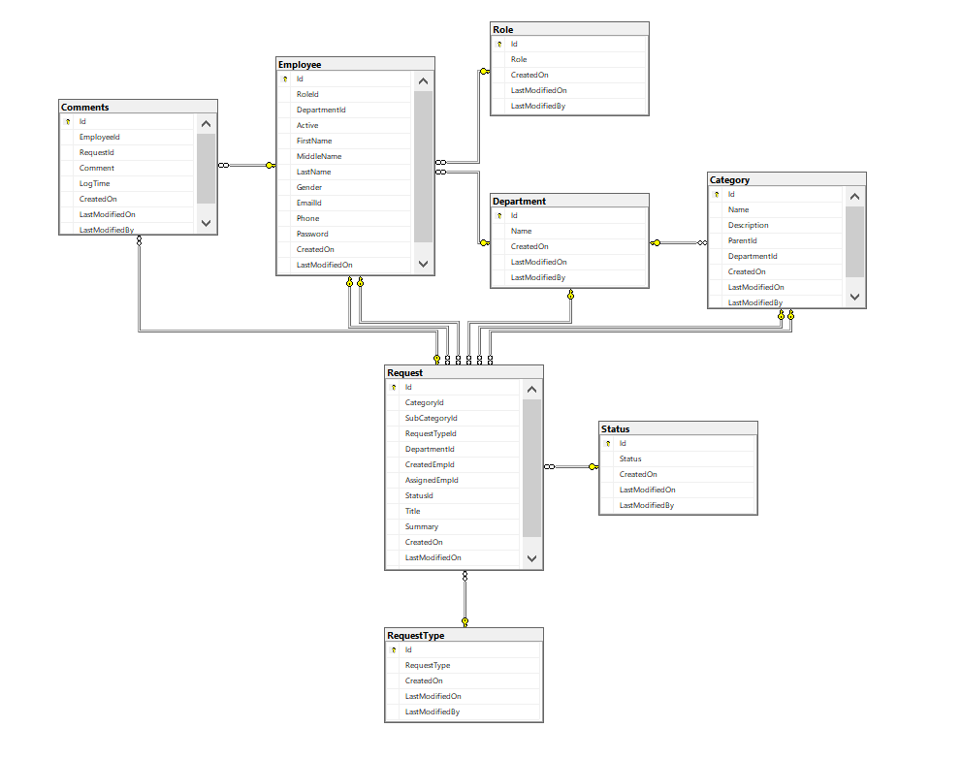

## default value in tables

* Role: [Admin, associate, resource]
* Status: [Open, InProgress, Close]
* Request type: [Service, Issue]

## 3.3 Middleware Overview

* Setup information for mail server with proper settings
* Create API For Department-wise request to admin user.

# 4.requiremrnts

## 4.1 Technical Requirement

* Front End must be developed using Angular 9+ and may use Angular material for development
* Database Should be designed with Microsoft SQL Database
* Use Asp.net core 3.1 for middleware API creation

## 4.2 environmental requirement

* For backend side development Asp.net 3.1 needs to be installed.
* For frontend deployment angular 9+ versions need to be installed.
* For accessing admin panel try to use latest Chrome, Mozilla or edge browser.

## 4.3 Functional Requirement

* After Updating Request all stakeholders (request creator, employee whom request assigned) involved in request should be notified via mail.
* A system should handle multiple account login at a same time.
* Data stored in database should have audit fields like created date, modified date, last modified by which should be maintained by system.

## 4.4 support requirement

* Database need to be backup frequently.
* New registered user needs to be given department and role via database admin.

# 5. Constraints

* Request with InProgress cannot be changed to open, But Close Request can be Opened.
* Request Must Be Assigned to Employee within the department Having Resource Role.

# 6. workflow

## 6.1 Wireframe diagram

* Login Page

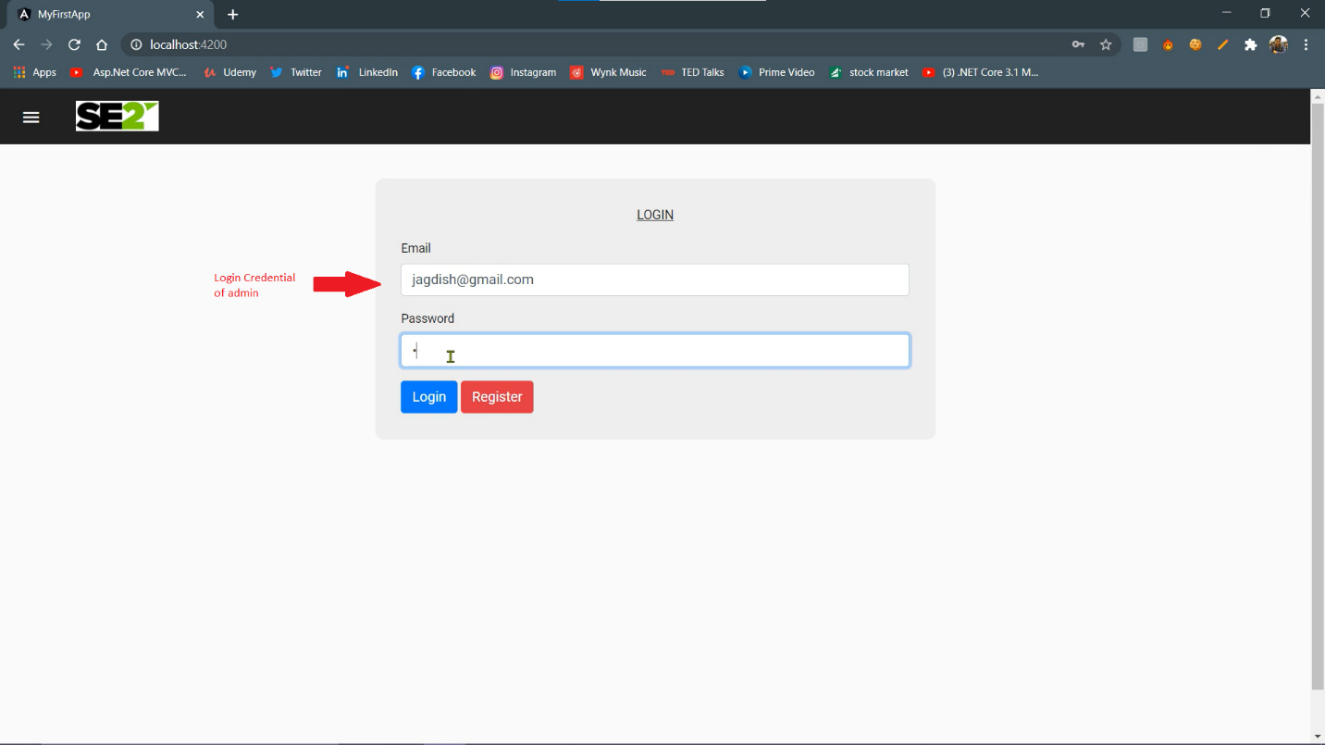

* Request List Page (After login)

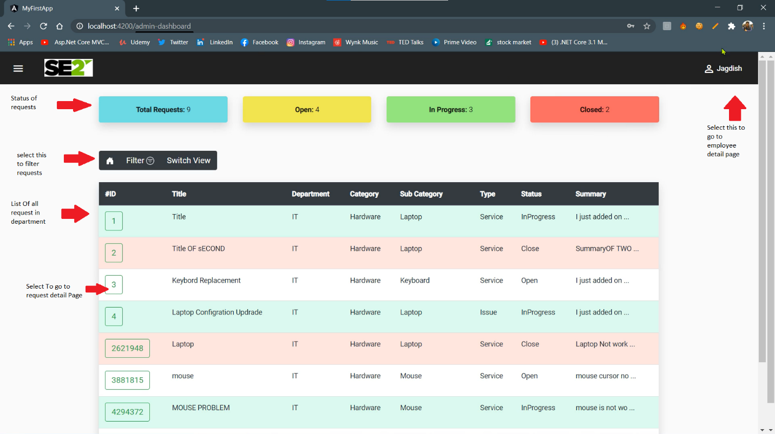

* Filter Section

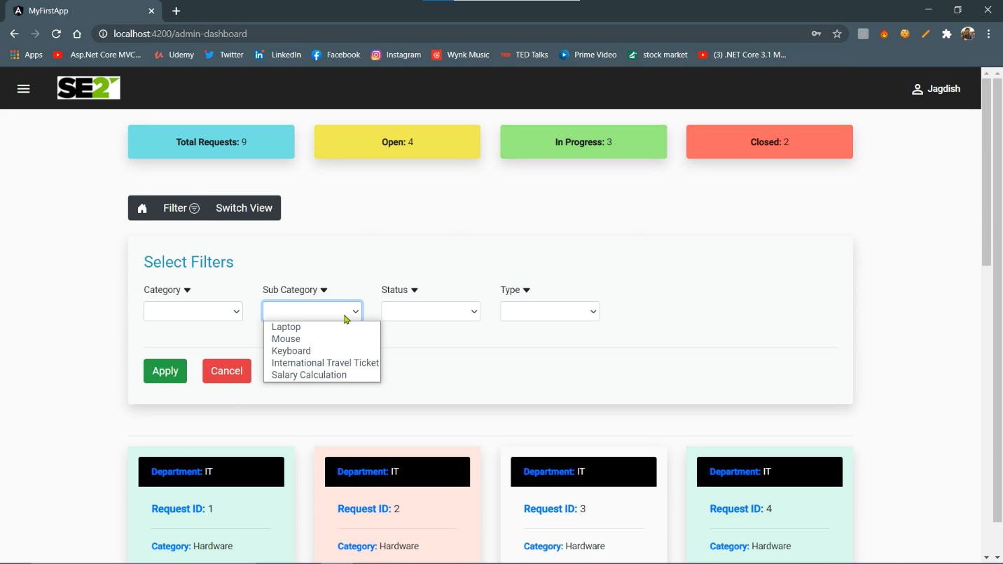

* Request Detail Page

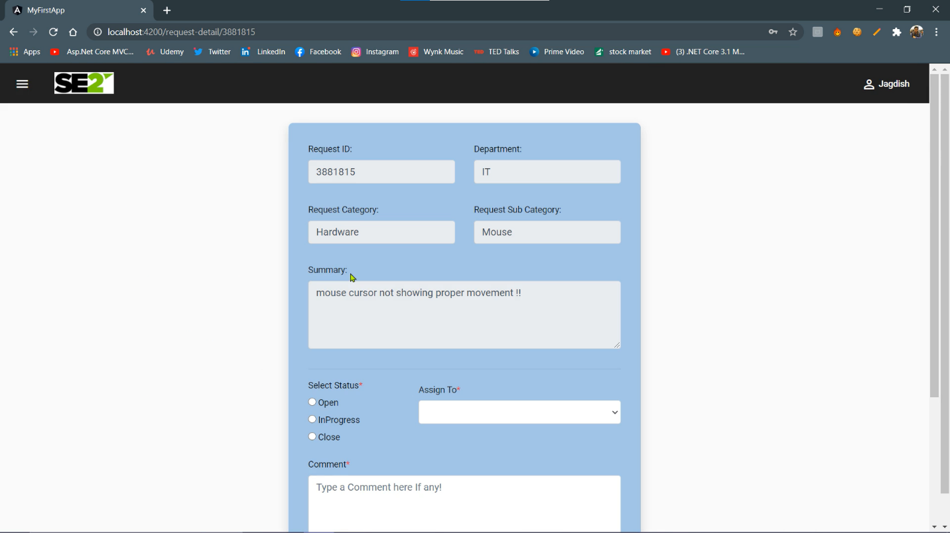

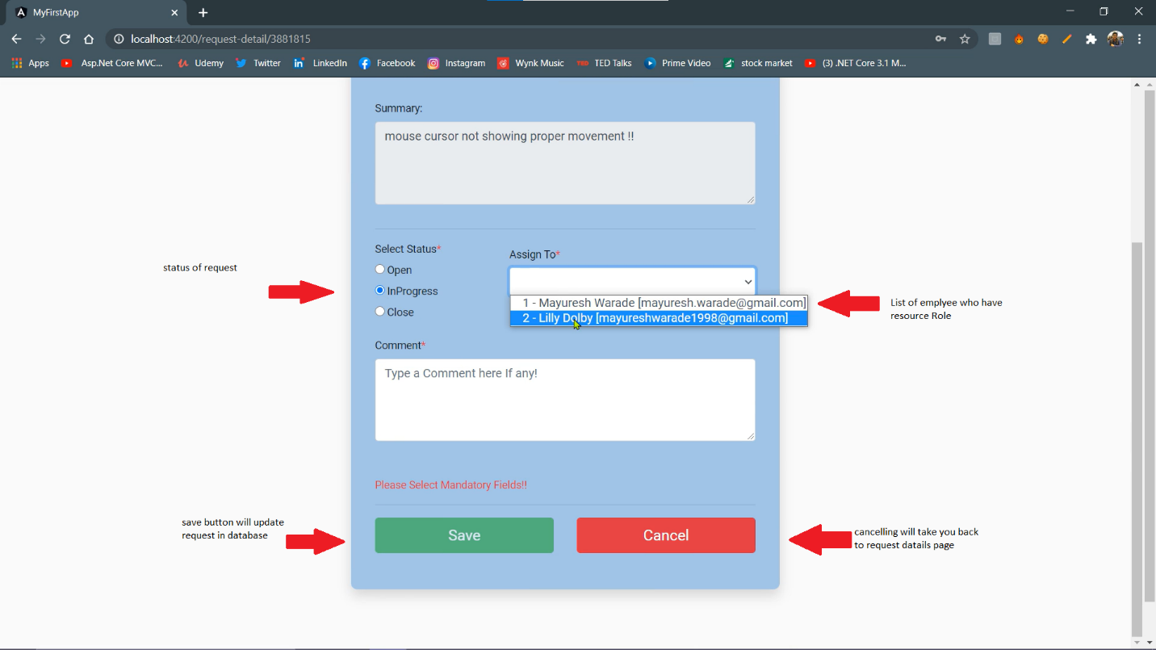

* Employee Detail page

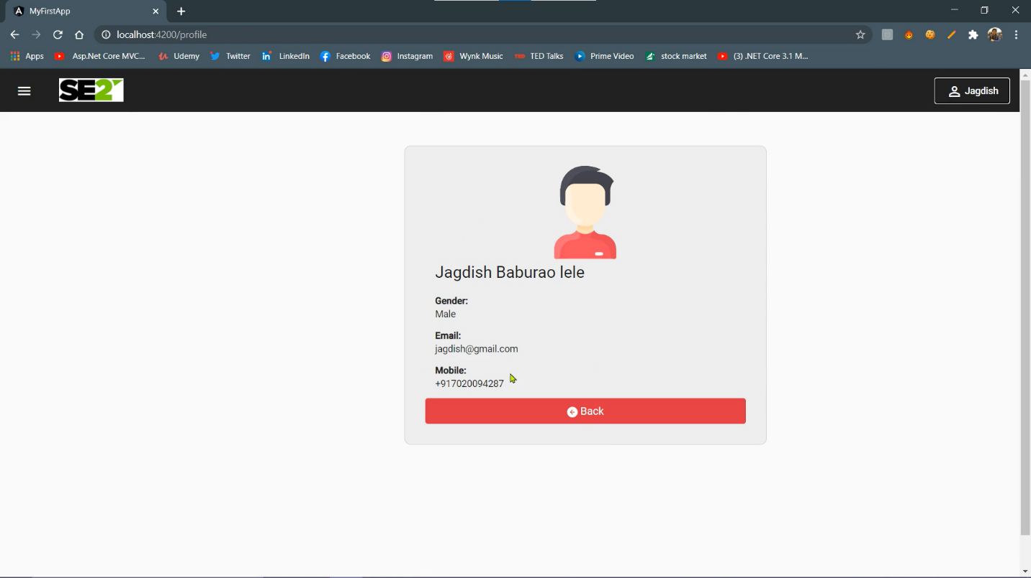

# 7. Evaluation Plan and performance matrices

## 7.1 Evaluation Plan

## 7.1.1 Outcome and impact

* Login to Admin panel should show every request generated in department
* All action buttons in panel should be visible/ interactive to user.
* After updating request user should be notified on screen.

## 7.1.2 Evaluation method

* First developer should fulfill all the requirement mention in this document.
* Internal People will evaluate all aspects of software. like ease of use, UI, Database Transactions, API behavior.
* Internal person will analyze API, and review transitions in database.
* Internal person will also look for consistency for UI.
* After reviewing internal person should have list all observation in report.

## 7.2 Performance metrices

* Time to load data should be minimum (less than 0.5 sec).
* Data should be auditable.